

Specification

for

SQL diagnostic manager (Project Houston) Collection Service

Jon Stelly

5/10/06



Proprietary and Confidential to BBS Technologies, Inc.

© 2006 BBS Technologies, Inc.; all rights reserved.

Revision history:
When? | Who? | What?
5/10/06 | Jon Stelly | Initial Draft

Table of Contents
1. Revision history: iii
2. Table of Contents iv
3. Requirements 1
3.1. Overview/Purpose 1
3.2. Glossary 1
3.3. FAQ 1
3.4. Major Features 1
3.4.1. Collects Scheduled Metrics 1
3.4.2. Collects On-Demand Metrics 2
3.5. Open Issues 2
3.5.1. Scalability Target? 2
4. Functional Design 3
4.1. User Interfaces 3
4.2. Installation and Upgrade 3
4.3. Permissions and other Required Configuration 3
4.4. Licensing Issues 3
4.5. Dependencies 4
4.5.1. Dependencies on Idera Software 4
4.5.2. Third-Party Software Required on the Customer Machine 4
4.5.3. Third-Party Software Required Internally 4
5. Internal Design 5
5.1. System Architecture 5
5.2. Physical Architecture 5
5.3. Configuration Information 5
5.4. Scheduled Collection 6
5.5. On-Demand Collection 7
5.6. System Health 7
5.7. Collection Service Subsystems 8
5.7.1. Monitoring Subsystem 8
5.7.2. Scheduled Collection Subsystem 8
5.7.3. On-Demand Collection Subsystem 9
5.7.4. Configuration and Caching Subsystem 9
5.8. Work Breakdown and Sizing 9
5.8.1. Areas of Risk 10
6. Quality Assurance Considerations 10
6.1.1. Overview 10
6.1.2. Developer-Created Unit Tests 10
7. Documentation Considerations 11
8. Bibliography 11

Requirements

Overview/Purpose
The Collection Service handles communication with the monitored SQL Servers. This communication includes scheduled collection as well as on-demand collection. The Collection Service also performs threshold comparison on the scheduled collection metrics, sending back threshold events and metrics to the Management Service, either to be stored in the SQLdm Repository or forwarded to the client in the case of on-demand data.

Glossary
- Management Service – The service that functions as the central aggregator for the SQL diagnostic manager architecture.
- Collection Service – The service that collects metrics from a set of monitored servers and transmits those metrics to the Management Service.
- SQLdm Repository – The central repository used for storing scheduled collection snapshots and configuration information for the SQL diagnostic manager architecture.
- Desktop Client – The client application for viewing SQL diagnostic manager data, configuring monitored servers, etc…
- Scheduled Collection – The act of collecting snapshots on a scheduled basis. These scheduled collections can trigger notifications and some of the data points are stored in the SQLdm Repository.
- On-Demand Collection – The act of a client requesting current data for a monitored server. This happens as a result of a user opening up a view in a client. Not all client views use On-Demand data. Once a user has an On-Demand view open, On-Demand data is requested for that view at a interval specified on the client.
- Threshold – Thresholds are used to determine if a data point is within an acceptable range (OK), in a warning state or a critical state.

FAQ
Ask and ye shall be answered.

Major Features

Collects Scheduled Metrics
The Collection Service is responsible for collecting scheduled metrics snapshots from all monitored SQL Servers, checking the collected values against user-configured thresholds and determining the status of these values. After computing the statuses, the Collection Service sends snapshots that need to be stored in the SQLdm Repository, threshold violation and state-change events back to the Management Service to be logged and possibly to have notifications sent depending on the notification rules established by the user.
The snapshots that are stored in the SQLdm Repository will be sent back to the Management Service when they’re collected even if the snapshot didn’t generate any events. For snapshots that are not stored in the SQLdm Repository, those values will still be collected and checked against thresholds, but onlythe values that generate an event will be sent to the Management Service when attached to the event information.
The Collection Service will maintain the last collected status information for all monitored servers. This previous state information is used to determine if a state-change event has occurred. It will also keep a single previous collection value for some parameters where we collect a raw value and require the previous data point to compute a more user-friendly value.

Collects On-Demand Metrics
Requests for on-demand data from the clients will be routed through the Management Service and forwarded to the Collection Service. The Collection Service then collects the data requested and returns it to the Management Service to be returned back to the client. The Collection Service performs no threshold lookup or comparison for on-demand metrics.

Open Issues

Scalability Target?
On the following hardware, a single-box middle-tier install (Management Service, Collection Service, SQL Server 2005 Standard), We’re aiming to support scheduled collection of 200 monitored SQL Servers, assuming all SQL Servers are on a LAN segment, averaging 25 databases with 60-70 tables each, collecting every 6 minutes and no collection taking longer than 30 seconds. At those numbers, it equates to around 325,000 row inserts into the repository for the various statistics tables and 6,000 threshold / previous state checks every 6 minutes.
Module | Description
PowerEdge 2850 | Dual Core Intel® Xeon™ Processor, 2x2MB Cache, 2.8GHz, 800MHz FSB
Additional Processor | Dual Core Intel® Xeon™ Processor, 2x2MB Cache, 2.8GHz, 800MHz FSB
Memory | 4GB DDR2 400MHz (4X1GB), Single Ranked DIMMs
Primary Hard Drive | 146GB 15K RPM Ultra 320 SCSI Hard Drive
2nd Hard Drive | 146GB 15K RPM Ultra 320 SCSI Hard Drive
Hard Drive Configuration | Drives attached to embedded PERC4e/Di, RAID 0

TOTAL:$3,967.26

Functional Design

User Interfaces
There will be no User Interface for the Collection Service. All scheduled collection or on-demand configuration will be provided by a client and forwarded to the Collection Service from the Management Service.

Installation and Upgrade
Three installation features will be provided. One to install the middle-tier (Management Service & Collection Service), one to install the SQLdm Repository, and one to install the Desktop Client. The user can pick and choose which features he wants installed on any given machine. For this release the Management Service and Collection Service must reside on the same machine.
Required Software:
- MDAC 2.8 (for connecting to SQL Server 2005)
- .NET Framework 2.0
Supported Operating Systems for the middle tier:
- Windows 2000 SP4
- Windows Server 2003
- Winows XP SP2
Supported Monitored SQL Servers:
- SQL Server 2000 Standard & Enterprise with SP 3
- SQL Server 2005 Standard & Enterprise

Permissions and other Required Configuration
Only connections from the configured Management Service will be accepted on the Collection Service. When collecting from a monitored SQL Server, the user account the Collection Service runs as will be used if integrated security is specified. Otherwise the user must supply the SQL Server authentication information when registering the monitored SQL Server. All passwords used for collection will be encrypted in memory until needed to establish a connection.

Licensing Issues
The licensing scheme for Project Houston is still undetermined. Whatever scheme is used, the licensing information will be stored in the SQLdm Repository. The Management Service will probably do some basic checks upon startup to ensure that the number of monitored servers doesn’t exceed the licensing. The Collection Service will likely not directly enforce licensing, but will only monitor servers sent to it after the Management Service determines there is a monitoring license available.

Dependencies

Dependencies on Idera Software
Idera Licensing Library.

Third-Party Software Required on the Customer Machine
MDAC 2.8
.NET 2.0

Third-Party Software Required Internally
The Collection Service depends on log4net for its logging functionality and possibly #ZipLib for compressing large chunks of text (various log-files) before sending them across the network.

Internal Design

System Architecture
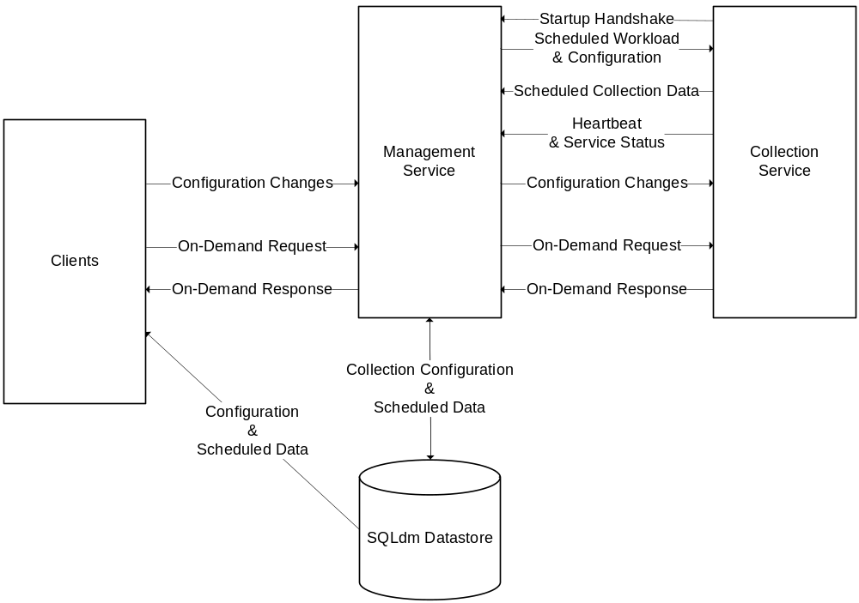
In this version of SQLdm there will only be one supported configuration: A single middle-tier with a single Management Service and Collection Service installed on the same machine. There is no plan to limit the number of clients that may request on-demand data at any given time. If we determine that on-demand data places too high a load on the system during testing, we may offer a way to limit the number of clients.
The Collection Service communicates only with the Management Service and the SQL Servers it is monitoring. All requests from clients will be relayed through the Management Service.

Physical Architecture
The Collection Service will run as a Windows Service written against the .NET 2.0 Framework. In this release the Management Service and Collection Service must reside on the same machine.

Configuration Information
Upon startup, the Collection Service will attempt to contact the configured Management Service. If it cannot contact the Management Service, it enters a loop, sleeping 15 seconds (configurable via the .config file, as the disconnected timer value) and attempting to contact the Management Service again until successful. Once the Collection Service is able to connect to the Management Service, it sends the GUID for the Collection Service and gets back its scheduled collection workload and configuration. This information includes:
- A Collection Service Session GUID
- The list of monitored SQL Servers the Collection Service is responsible for and their connection information
- The thresholds configured for those servers
- Schedules for the normal collection and the quiet-time schedule for those servers
- Previous state of all values for those servers that have thresholds.

Scheduled Collection
The Collection Service will start collecting snapshots based on its scheduled collection workload received upon startup. After collecting these values, the Collection Service:
- Checks against the user-supplied thresholds for the monitored SQL Server
- Computes user-friendly values from raw values where needed (@@CPU_BUSY to CPU Utilization %, etc…) This is done using a Raw Value Helper cache that maintains the last scheduled collection value for these raw fields. This same cache will be used by On-Demand data to prevent a 1-collection delay from showing up on client screens where possible.
- Determines the current state of all values collected that have thresholds. (See Batch Specification for details on which values have thresholds)
- Determines if any state change events occurred by comparing this new state against the previous state for that value. This is done by using a Previous State cache that keeps track of the state of values on the previous scheduled collection cycle.
- Transmits back to the Management Service the collected values that are stored in the SQLdm Repository, along with event information for any events that occurred. The thread pool thread used to perform the 4 previous steps will take the output data and place it on a queue which a worker thread will monitor and remove items from for transmission when signaled that new data is available on the queue. If the Management Service is unavailable, the queue will continue to grow and will be persisted to disk until it’s local caching limit is reached.
There are two types of scheduled collection for a monitored SQL Server. There is a normal collection cycle that happens every 6 minutes by default (user-configurable per-server). This collection starts every time the interval elapses. If for some reason the previous collection has not completed by the time the interval elapses again, then this second collection is canceled and a system event is raised so it can be logged and possibly sent out in a notification.
The second type of collection occurs once daily at a pre-configured time. This collection should be scheduled for a time when the monitored SQL Server is under a low load if possible. This collection contains the table reorganization and growth information and is somewhat expensive to collect on the monitored server. This collection can be scheduled to only occur on certain days of the week, and databases and/or system tables can be excluded from this collection. This schedule provides a start and end time, where collection begins at the start time, and if it fails before the end time, will be retried at the normal collection interval until the end time elapses or the data is collected successfully. If the end-time elapses and this collection hasn’t finished, then the collection is considered to have failed.
If either of these collections fails, this will raise a generic collection event that puts the object we’re collecting for into the Critical state. Neither of these scheduled collections occurs if the server is flagged as being in blackout mode. This blackout mode is set and unset on the client on a per-server basis.
Scheduled data includes (See Batch Specification for details)::
- SQL Server Summary and Statistics - scheduled refresh
- Database Overview and Statistics - scheduled refresh
- Worst Performing - scheduled refresh
- Database Space (Growth) - quiet time
- Table Statistics (Reorganization and Growth) – quiet time

On-Demand Collection
When a client requests an on-demand snapshot for a particular view, the request is sent to the Management Service which forwards the request to the Collection Service. The Collection Service collects the data and returns it to the Management Service. The Raw Value Helper cache is used to compute user-friendly values where needed and possible, but no threshold checking is done on the data.
On-Demand data includes (See Batch Specification for details):
- Agent Summary
- Agent Job History
- Agent Log
- Database Details
- Full-Text Search Catalog Status
- Index Details
- Locks
- Memory
- Open Transactions
- Performance Counters
- Procedure Cache
- Processes
- Replication Status
- SQL Server Log
- SQL Server Summary and Details
- Table Details
- Transaction Log

System Health
The Collection Service will send heartbeats to the Management Service at a scheduled interval. This interval is stored in the SQLdm Repository and retrieved from the Management Service in the initial Collection Service workload. The Management Service uses this heartbeat to ensure that the Collection Service is up and functioning. If 1.25 (or maybe 1.5) times the heartbeat interval elapses on the Management Service without receiving a heartbeat from the Collection Service, a system event is generated and notifications sent from the Management Service if a user has configured notifications for this event.

Collection Service Subsystems
The Collection Service’s code will be split into 4 subsystems. This will allow multiple developers to contribute to coding, help isolate testing of each subsystem and allow for easily moving around subsystems in the event that a future version of SQL diagnostic manager requires some architectural changes.
The threading model of the Collection Service will use a single thread for most communication that originates from the Collection Service (The heartbeat messages will be the main exception to that rule). This includes the initial startup and requesting of the scheduled workload / Collection Service Session information. This thread will issue the request to the Management Service for a new session and its workload, wait for the response and start timers for the scheduled collection and a timer for sending scheduled heartbeats. This main thread then begins listening for events on the Scheduled Collection Data queue and removing objects from the queue and sending to the Management Service as they’re placed on the queue.
The timer started for heartbeat messages (5 minutes by default, configurable in the SQLdm Repository) will open a remoting connection to the Management Service and send a heartbeat message, checking the return code. This return code is checked so the Collection Service knows if it can communicate with the Management Service. If not, the Collection Service enters a disconnected mode, where the interval for the heartbeat timer is reduced to 15 seconds (the same disconnected timer value used for initial startup, configurable in the .config file) to check more aggressively if the Management Service connection is available. The goal here is to reduce latency in the system from possibly brief network interruptions, and to not have to cache any more data on the Collection Service than is absolutely needed.
The timers started for scheduled collection will elapse and fire on thread pool threads, where the probe will be launched to collect data. These probes will work asynchronously, sending the request and allowing the response to occur in the thread pool again. In this asynchronous delegate, the probe will return the collected data, and the work needed to be performed on that data (threshold checks, previous state checks, pushing the final data onto the transmission queue) will take place.

Monitoring Subsystem
This subsystem represents the code that deals with connecting to and collecting data from the monitored SQL Servers. It is used by both the Scheduled Collection Subsystem and On-Demand Collection Subsystem. This is mostly the probes for collecting snapshots, the snapshot data structures, structures that contain the connection / query timeout values along with some utility code to help deal with the asynchronous probes.

Scheduled Collection Subsystem
This subsystem will contain the logic to schedule and collect data using the Monitoring Subsystem. This includes the scheduled collection timers, threshold checking and state to previous state comparison logic, as well as the code to push data onto the scheduled collection data queue. The code that handles the scheduled collection queue and ensures data does not get lost from that queue will also be part of this subsystem.
The scheduled timers will open connections to a server (one for each batch) and begin the asynchronous queries to collect the batches. After this, the timer delegate method will exit and when the query completes, the delegate method passed to the asynchronous request will be executed to parse the returned data into a Snapshot, determine state, generate events and add this information to the transmission queue.
The queue will contain one entry per server per scheduled collection. When the scheduled data queue transmission thread is signaled that data is available, it will remove an entry from the queue and attempt to send it to the Management Service. If this succeeds the thread continues removing items from the queue until the queue is empty and sending them to the Management Service. If it fails, the Collection Service enters the disconnected mode, and the thread begins writing entries to a disk cache as they’re removed instead of sending to the Management Service.
When the Collection Service exits disconnected mode, the thread closes the file it’s writing entries to, opens it up for reading, and transmits all entries to the Management Service, then resumes monitoring the transmission queue.

On-Demand Collection Subsystem
This subsystem will use the Monitoring Subsystem to collect data requested by clients, but will not perform threshold checking or send events based on the data collected. It simply returns the snapshot objects requested back to the Management Service for transmission back to the requesting client.
On-Demand requests use the same asynchronous collection method as the scheduled collection. The only difference is that they’re initiated by a request from a client (by way of the Management Service) instead of from the scheduled collection timers. This request returns immediately, but passes in an object that is notified when the request completes.(either successfully or unsuccessfully).

Configuration and Caching Subsystem
This subsystem will handle storing configuration information and caching of the raw values for fields where we compute a user-friendly value based on two data points. This cache will be in-memory and not persisted between Collection Service restarts. This system is also responsible for scheduling collection based on the initial workload received from the Management Service, as well as updating those schedules and the associated collection information when changes are made from a client and forwarded from the Management Service.
When a change to the interval of a scheduled collection is made, the timer will be changed immediately. Any outstanding scheduled collection will continue and the collection will be scheduled for it’s first collection to happen at the current time + the new collection interval.
Thresholds for scheduled collection are not retrieved until the data has been returned from the monitored SQL Server. But at this point the thresholds are retrieved from the scheduled collection information and setting new thresholds will not take effect until the next scheduled collection.

Work Breakdown and Sizing
Component | Who | Sizing
Infrastructure (layout, implementation of basic infrastructure, threading model, namespaces, exception handling, logging) | Jon | 3 days
Global Configuration (configuration objects read from and written to config file) | Jon | 1 day
Parsing workload from Management Service, handing off to scheduling subsystem | Jon | 3 days
Remoting Interfaces (code for remoted objects hosted for the Management Service) | Jon | 2 days
Monitoring Subsystem (invoking probes, returning results) | Jon | 5 days
Raw Value Helper cache | Jon | 3 days
Previous State cache (status objects to mirror snapshots, caching mechanism to store previous state, populate cache during initial workload retrieval) | Jon | 3 days
Scheduled Collection Execution and Transmission (scheduling collection, retrieving data without checking thresholds or generating events, but pushing snapshots back to the Management Service) | Jon | 5 days
Add threshold checks to scheduled collection, generate events and attach to data to be sent back to the Management Service. | Jon | 5 days
On-Demand Subsystem (accepting requests for data, collecting, returning snapshot(s) | Jon | 5 days
Benchmarking and Optimization | Jon | 4 days
Bullet-proofing and refactoring, general code cleanup | Jon | 1 day
Total |  | 40 days

Areas of Risk
- Scalability potential looks pretty good right now, but will depend largely on ADO.NET’s asynchronous model (which is an unknown) meeting expectations.
- The Collection Service is a much more focused system than the Management Service, but will bear a significant portion of the work when the system is under load. Since it has many connections to various monitored SQL Servers with different performance characteristics, over a wide variety of networks… we need to focus efforts on giving the Collection Service the ability to gracefully handle as many of these situations as possible. This should be one of the main focuses of the development and QA effort for the Collection Service.

Quality Assurance Considerations

Overview
Verification of collected data from the Collection Service will be difficult. Currently we hope to offer a utility that uses our probe and snapshot library so QA can test the probes outside of the Collection Service, we’ll add plenty of debug logging to the Collection Service to help QA see values from the probes as they work their way through the Collection Service.

Developer-Created Unit Tests
TODO: Talk to QA to work up a plan for where we’d like to focus our unit test development work most.

Documentation Considerations
Any additions needed for the Glossary?

Bibliography

